# Experiment or Project Title: Lab 2 – Linux Commands

**Date: 03/26/2022**

**David Bates**

**CSCI3157-31 – Spring 2022**

**Summary:** In this Lab we try different Linux Commands Observe what happens and why it is important.

1. **Background:** Learning Linux is an amazing skill especially in the terminal due to Kali being based in Linux which is used a lot in Cyber Security fields for penetration testing as well as creating and sending malware. Therefore learning the basic commands is the basis of the operating system.
2. **Tools and System Specifications:** In this lab we have utilized the following tools:

* VirtualBox
* Linux Ubuntu

1. **Experimentations:**

**We executed the commands after showing you which commands I have done I will explain what it does.**

* **Cd -** 
  + **Returns to the home directory output of this command**
    - **/home/dbates**
* **Pwd**
  + **Displays the current working directory output of this command**
    - **/home/dbates**
* **ls -a**
  + **Displays a listing of current directory including hidden files output for this command:**



* **Ls -l /etc**
  + **This shows the /etc directory which stores storage system config files, executables which are required to boot the system, log files as well.**
* **Mkdir mydir**
  + **Creates a new directory called mydir and you can prove it by running ls to verify**

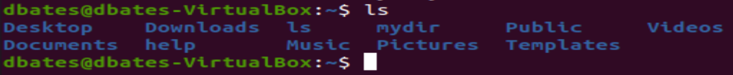

* **Cp myfile myfile2 followed by ls**
  + **Copies myfile to myfile2 and ls shows it in directory and verifys it**
* **“Cd mydir” followed by “pwd”**
  + **Cd mydir puts you in the directory and then the pwd proves that the directory exists and that it is working**
* **Cd .. then pwd then ls -a**
  + **Cd.. goes up one directory path (in this case goes up to /home) and pwd verifies it.**
* **Rmdir mydir**
  + **Rmdir deletes the directory following after it. You can use the ls command after to verify that its deleted**
* **Cp /etc/password myfile**
  + **Copied the file passwd from etc to the current directory**
* **Cp myfile myfile2**
  + **Copies myfile to a new file myfile2**
* **Rm myfile2**
  + **Myfile2 will be deleted and you can verify with ls**
* **Cat myfile**
  + **Views the content of myfile**
* **More myfile**
  + **Brings up the contents of myfile**
* **Cat myfile >myfile3**
  + **Copies the content to the new file myfile3**
* **Who**
  + **Generates a list of users on the system**
* **Cal**
  + **Brings up a calendar of this month**
* **Cal >thismonth**
  + **Creates a file called thismonth and stores the calendar data inside the file**
* **Ifconfig**
  + **Shows network parameters comparable to the ipconfig of windows os.**
* **Ping** 
  + **Allows you to ping other devices on the local network and even webpages to test if your internet is working**
* **Clear**
  + **Clears the terminal of all entries and outputs**

**The next Activity was to become the super user or, the root.**

* **Su –**
  + **Allows you to sign in to root**

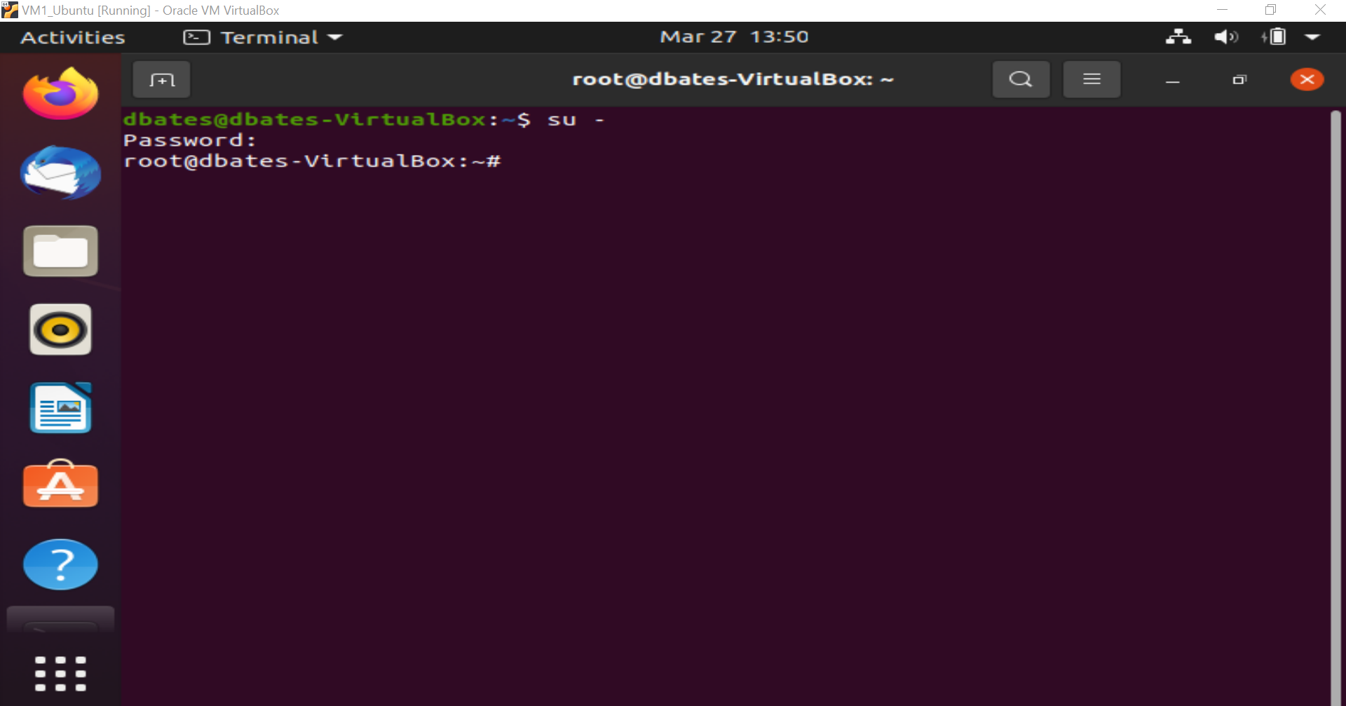

**You can then exit with the >exit entry and can do whoami to make sure youre on the regular path**

**The next module is creating and modifying files within the terminal**

**You can do this from your home directory and pulling up a file**

* **Nano myfile1**
  + **Bring us a dialogue box that we can enter data into the file myfile1**

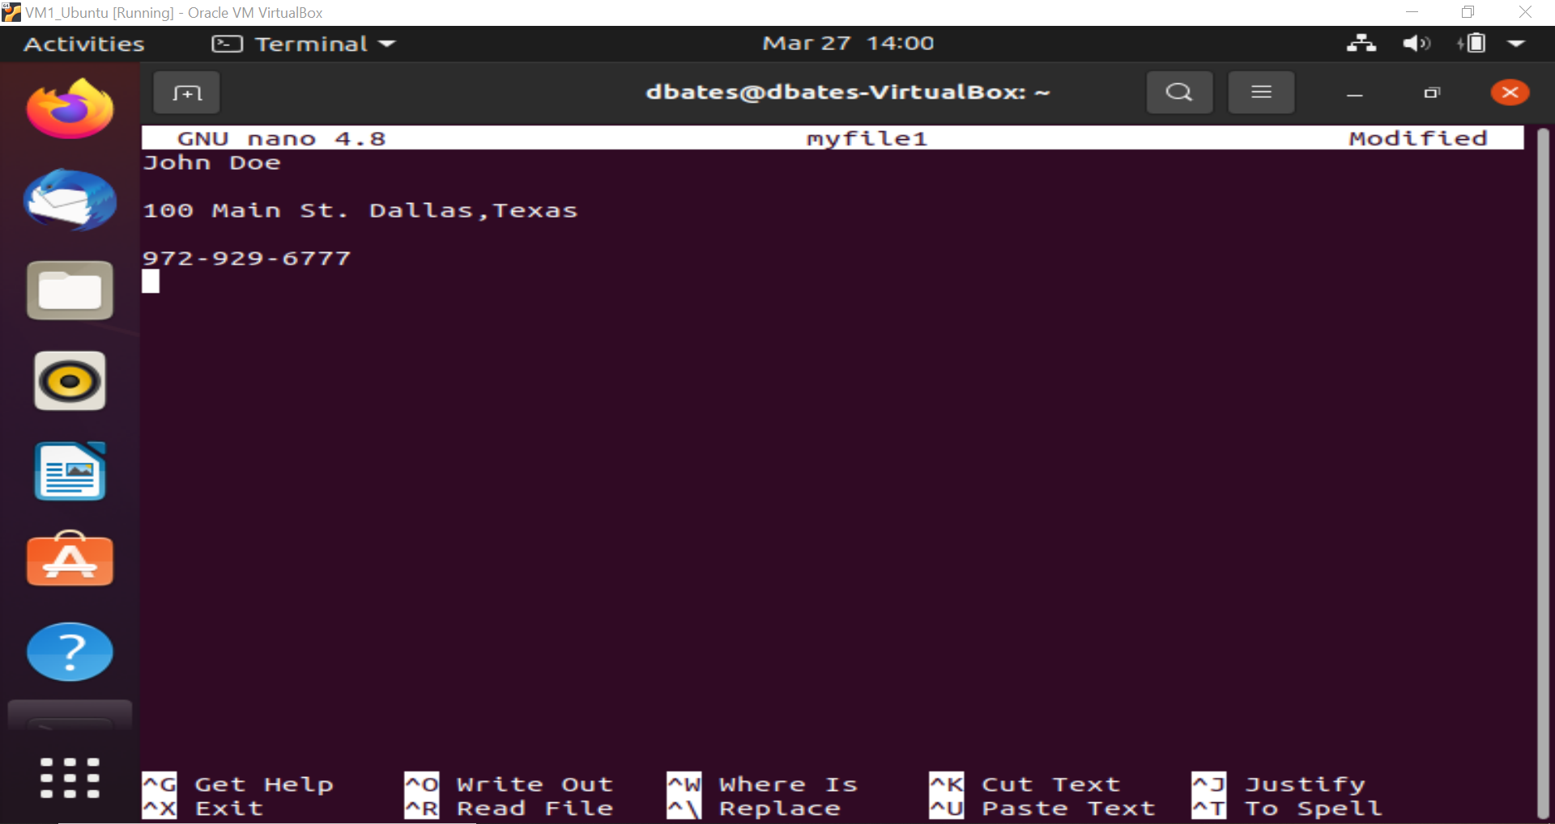**The controls at the bottom the “^” refers to the ctrl key so to exit we can press ctrl-O to save and then Ctrl-X to close the file and enter the terminal again.**

**By using the cat myfile1 similar to how we used the cat command last time it can bring up the contents of the file**

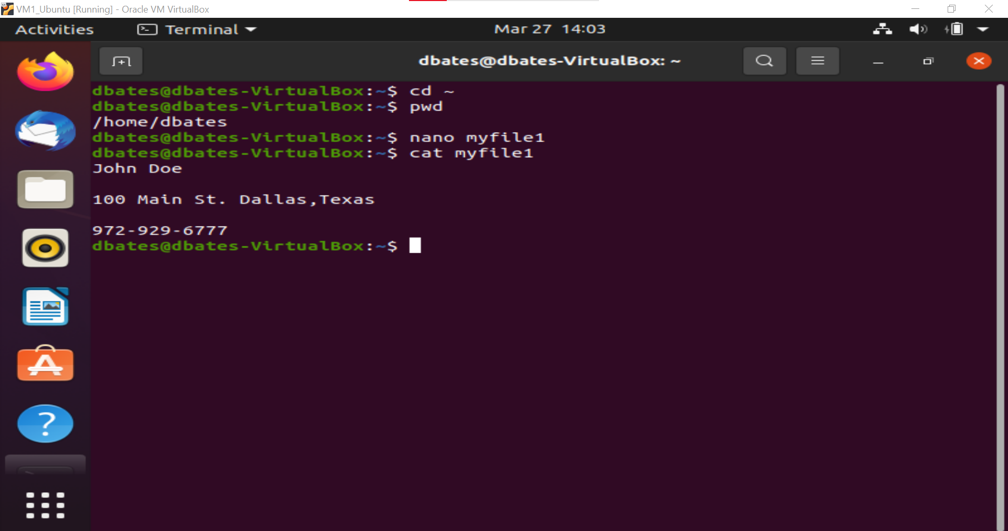

1. **Results, Discussions, and Conclusion:**

The results of this lab have taught me the basics of the Linux terminal hot to navigate through directories create new directories, create new files, show all files including hidden files, and even display the calendar/todays date. This lab has shown me the power of the terminal and how vulnerable a pc can be with access to it. Which is why passwords, antivirus software and other precautions should be taken to protect the integrity of your device.

1. **References:**

Linux command Part 1 lab on Webcampus.fdu.edu